CSC 621 Final Paper

Team 8

Hospital Management System

Mrs. Krueger/Mr. Nochenson

Mohammed Al-hazza, Seth Fields, Eleftherios Lazaridis, Yuchen Xun

12/6/2016

Hospital Management System - Team 8

Team eight proposed to build a hospital management system. The project focus on three type of major users: patient, employee, administrator. This paper exams the usage, implement constraints, how we ensure integrity, update and error check.

The following images indicate our final ERD and relational model. We separated some tables to make sure that if something gets deleted other related information will still be on record. For instance, if a patient gets deleted, the associated room will not.

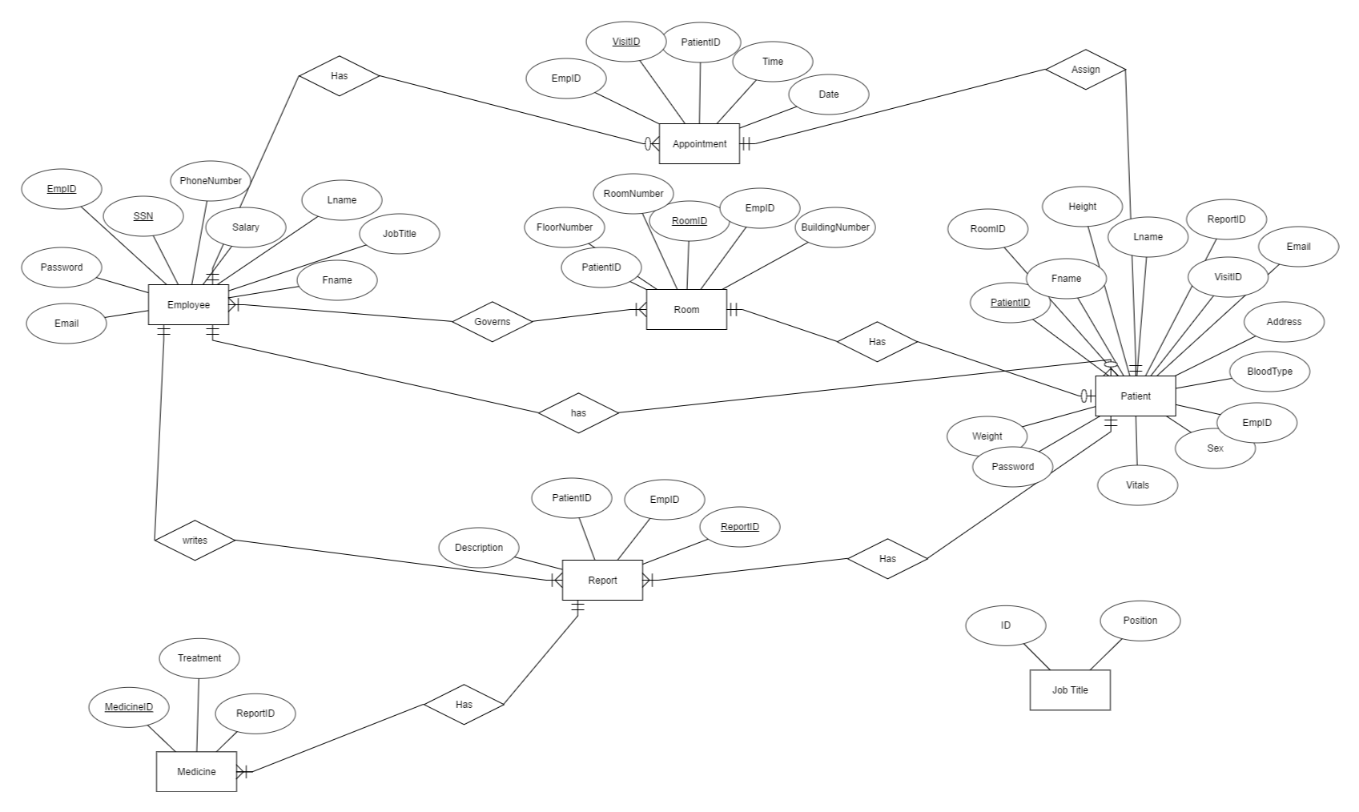

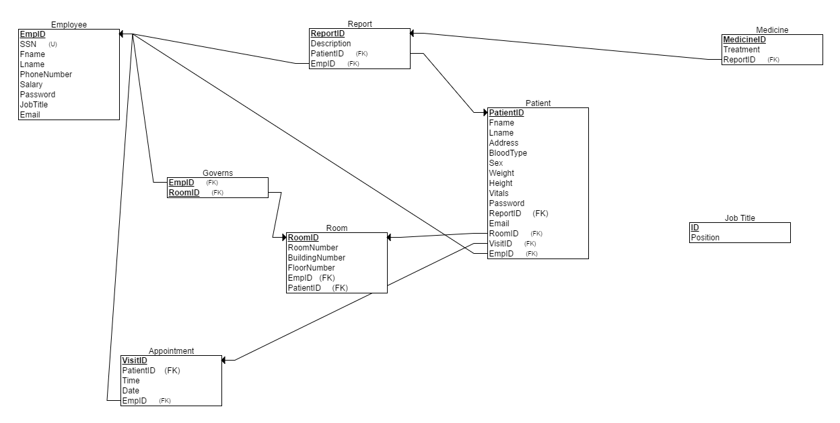

The main interface is simple and clean. Users login by entering their email and password. The system will determine the type of user based on the email address they entered. The attached image indicates the main interface. As you can see, except login function, we also provide users the option in case they forget their login credential.

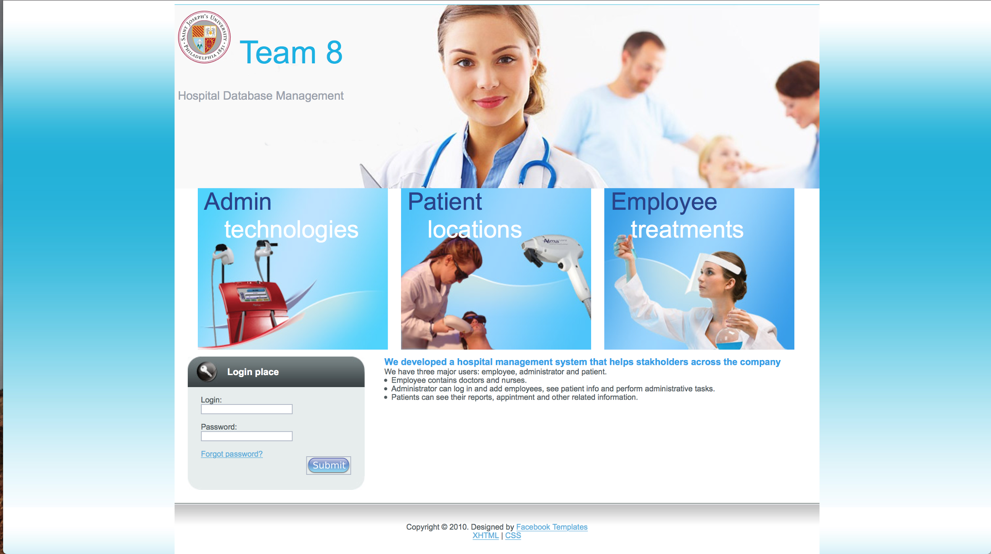

Our system contains three major types of users: Administrator, Doctor and Patient. Administrators are the only individuals that can monitor all activities at the hospital. A doctor will need to be able to retrieve reports from their patient’s records and status, check their appointments, enter treatments and billing information as well as medicine usage and search medicine prices and suppliers. A doctor can also cancel appointments. Administrators have the most accessibility to the system such as see all employees, check patient information, room usage and other related tasks. We think it is a very administrator friendly system. We believe the administrators can really use this system daily to edit, delete and update information for employees and patients. We intend the administrators to use this system heavily compare to the other two types of users.

The attached image below shows the main interface for administrators once they sign in using their email and password. Administrators have different tabs to access. We considered the position of administrators and we created the function for individuals to add employee and patient. To make it more convenient, administrators can also drop employees and patients. We see this as a major function since this can significantly help administrators to organize the company. 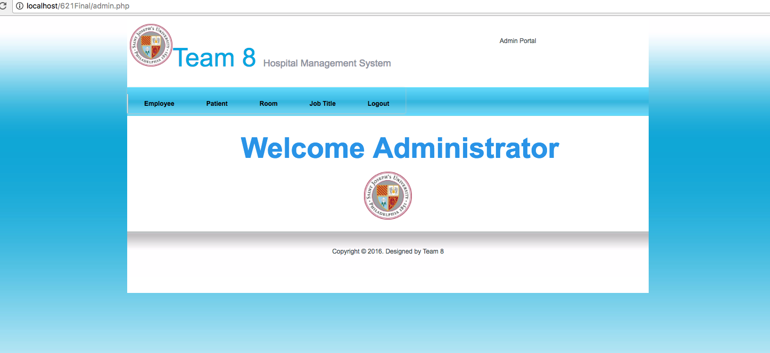

The following images indicate different tabs and functions administrators have across the navigation bar.

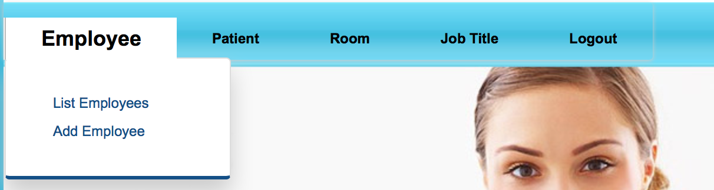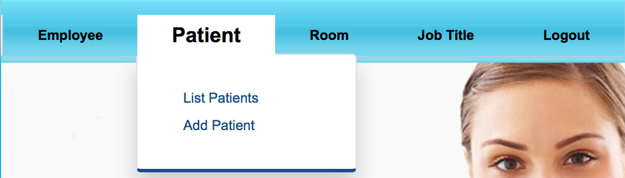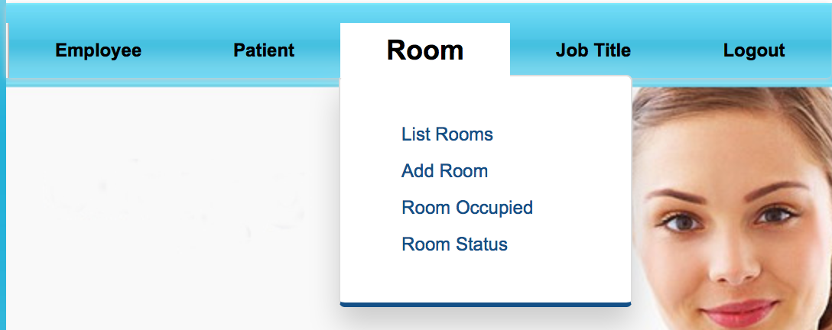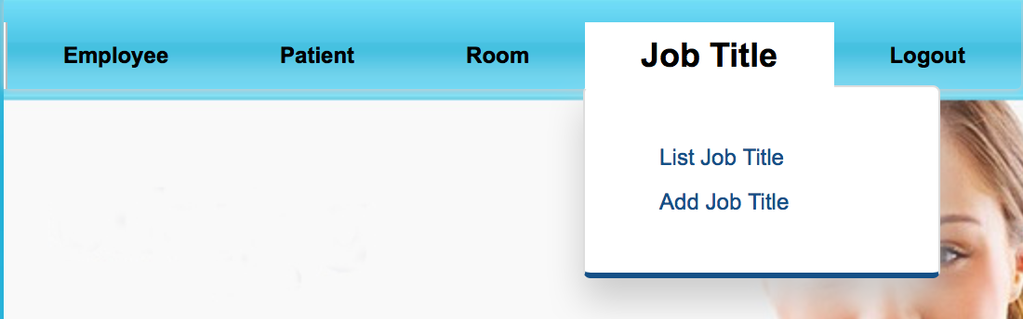

The picture below is list of employee page that administrators can see. Again, it really helps administrators to do daily tasks.

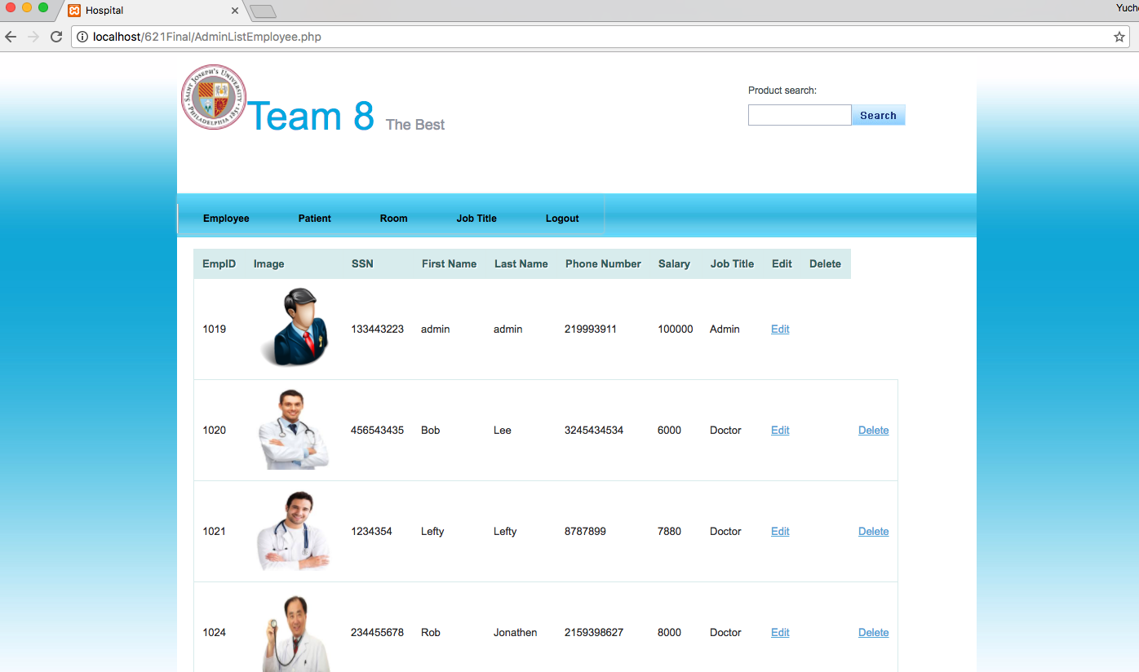

One highlight function we are proud of is that administrators cannot delete other administrators. We believe this function can eliminate ambiguity. As you can see in the picture above and below, administrators cannot delete other administrators:

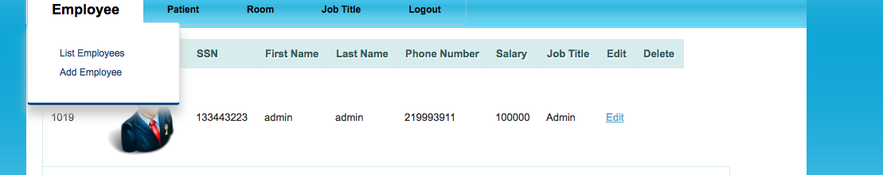

Administrators also can search for employees or patient. The drop down menu gives admin an option to choose between employee and patient:

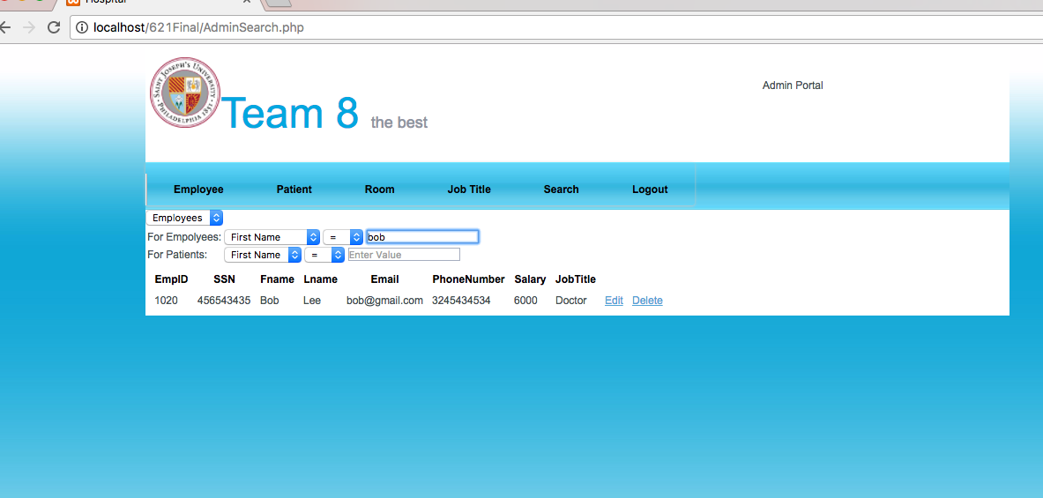

For Doctors, they can login by using their email and password. Once they are in the system, they can see patient reports. Doctors can add or edit reports. Doctors can see on the upper right corner with their name and the type of login. This picture shows what a regular doctor sees when they login:

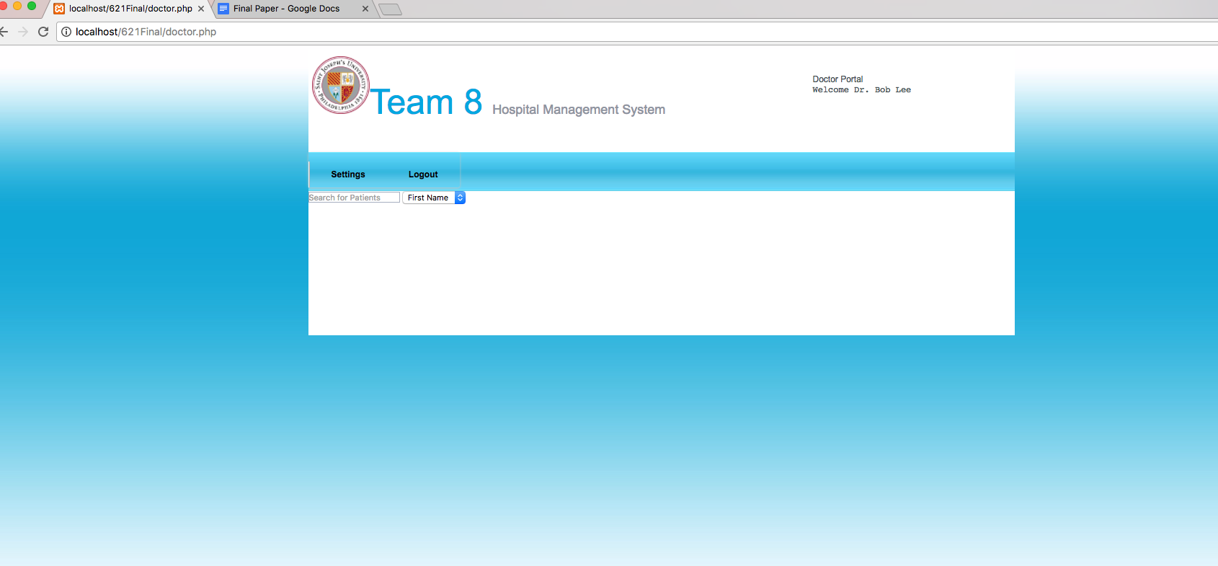

Doctors can also add new reports:

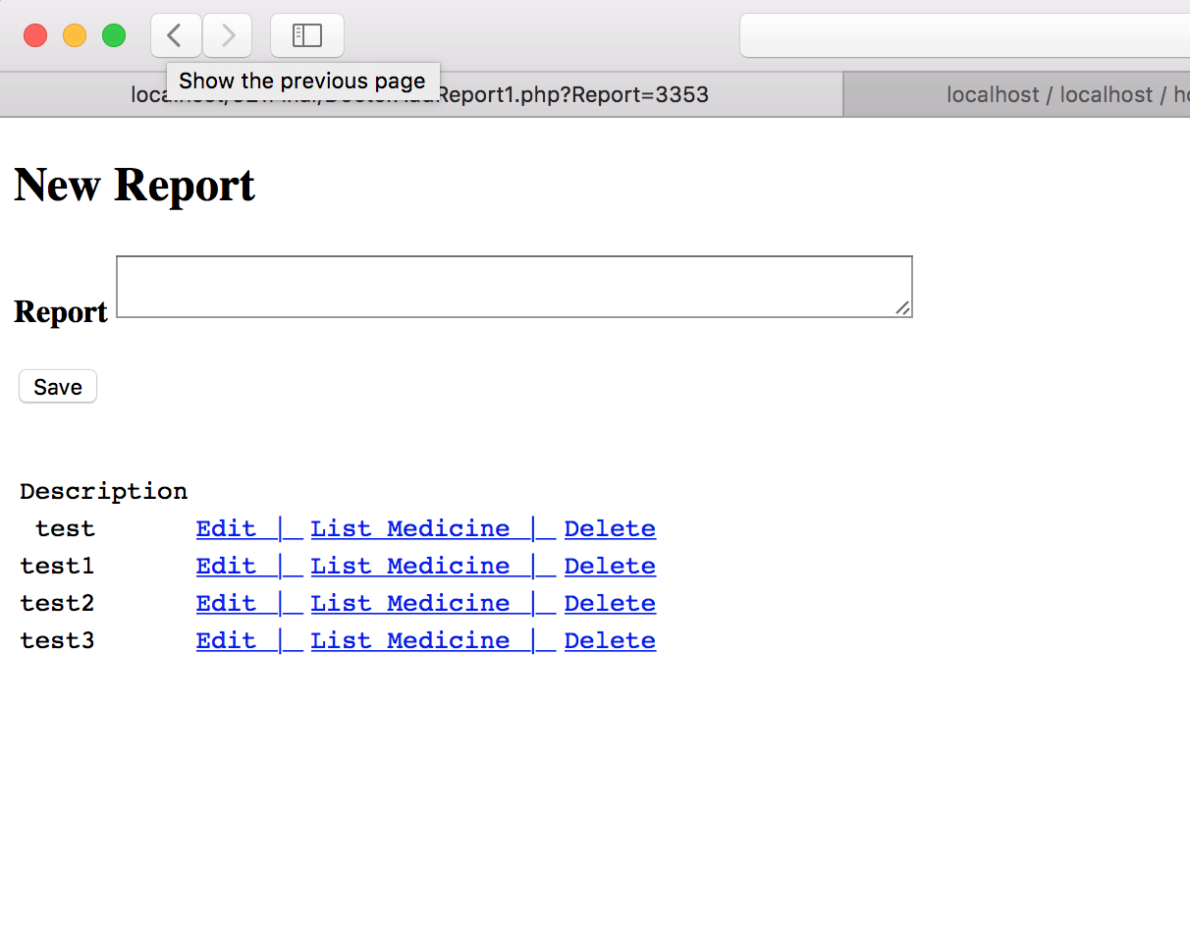

For doctors, we implemented Ajax to search for patients whose under the doctor’s care. The picture shows the method in Ajax:

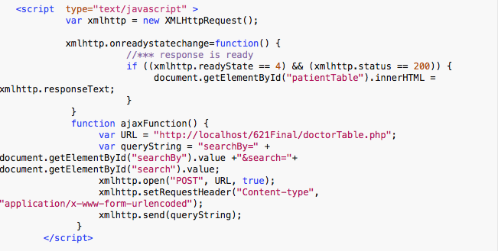

For instance, doctors can type in a patient’s name, then the result will be displayed:

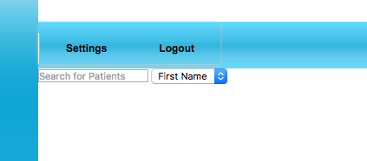

When the doctor search for the patient, the patients’ information is automatically shown.

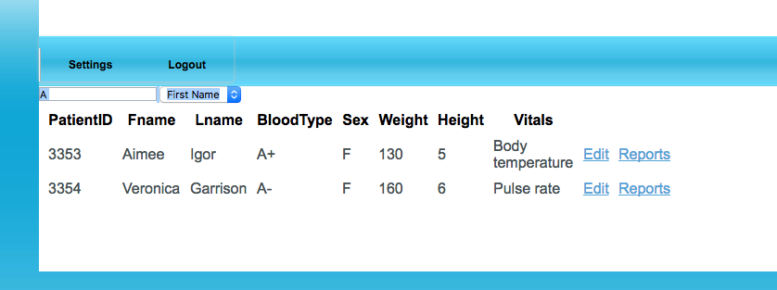

We also implemented the similar functionality for administrators.

For patients, they can see their test results, medicine they take and their profile. For instance, patient a uses email and password to log in and they can see:

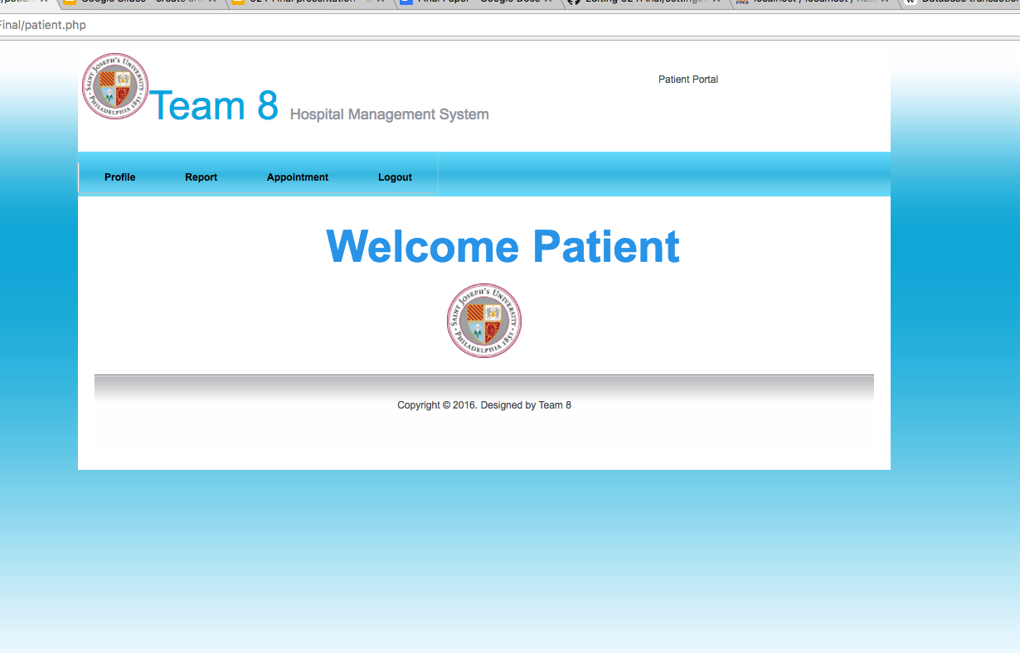

If they desire, they can click the profile button the access their personal information:

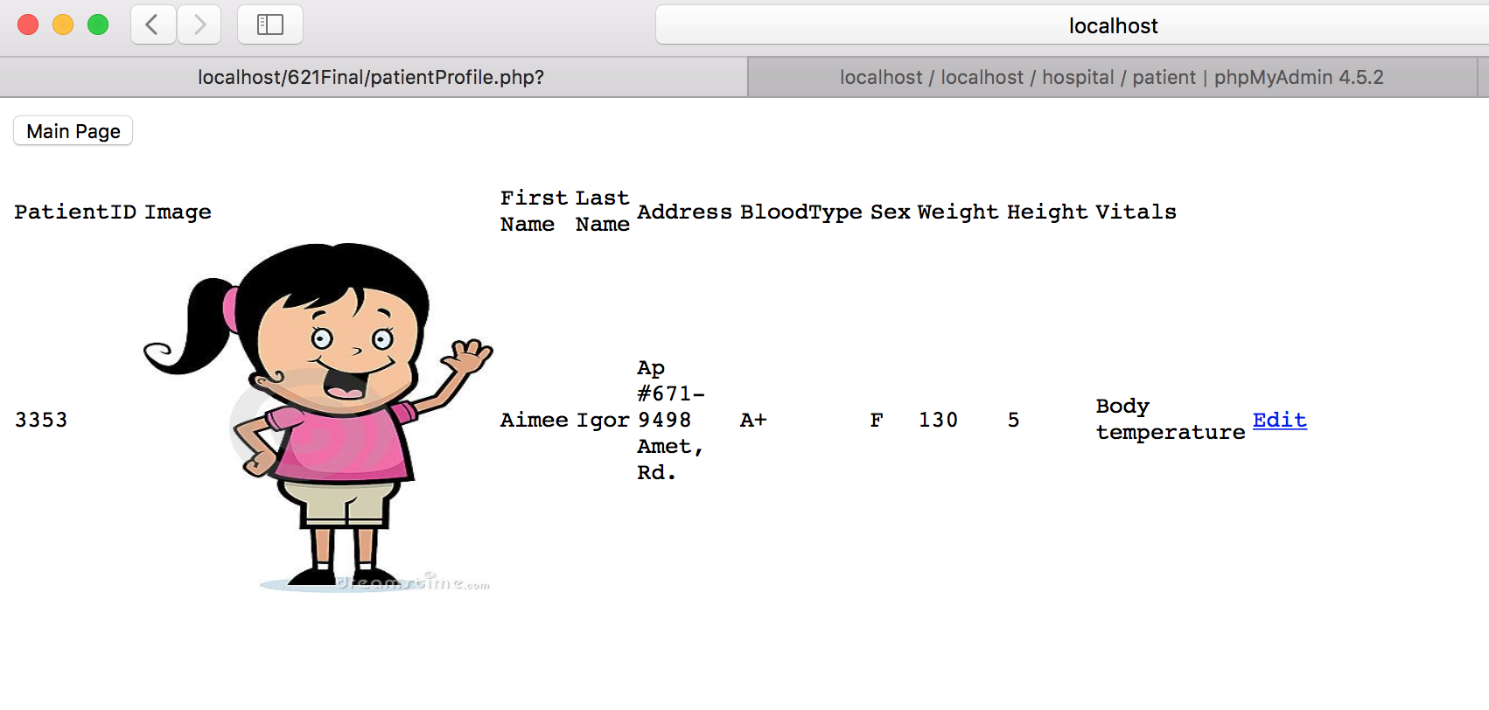

The following image shows the entire database:

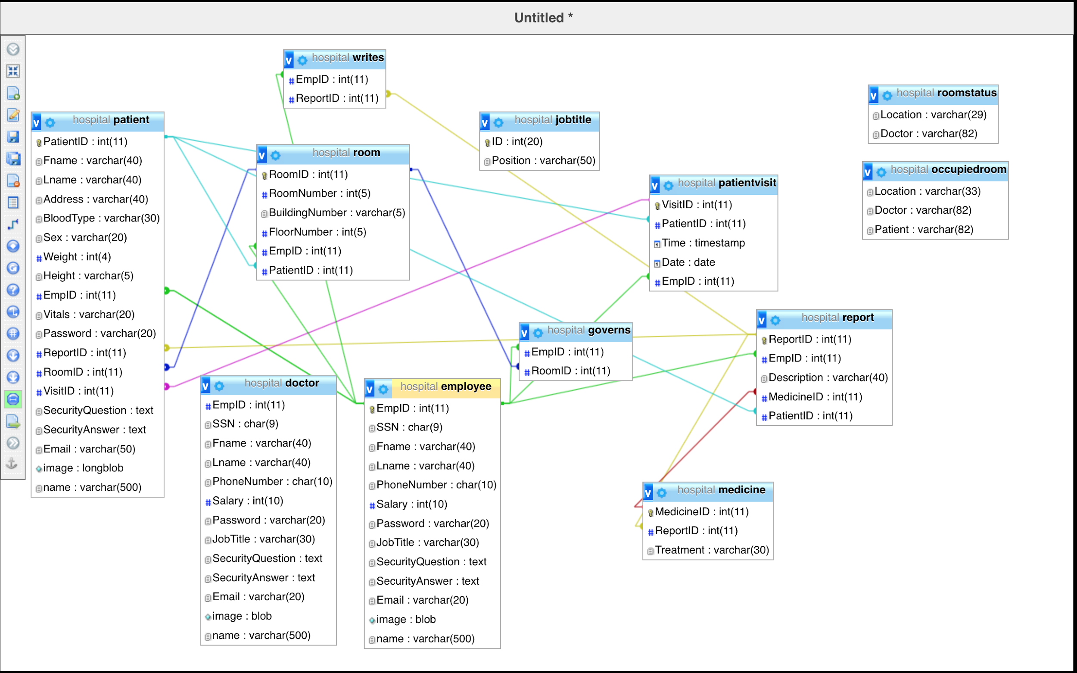

We also used **cascade** to ensure that doctors can delete medicines on reports. If you delete a particular patient, all related information will also be deleted. In addition, if the patient is assigned to a room, the room will become vacate. The picture shows our cascade function for our database:

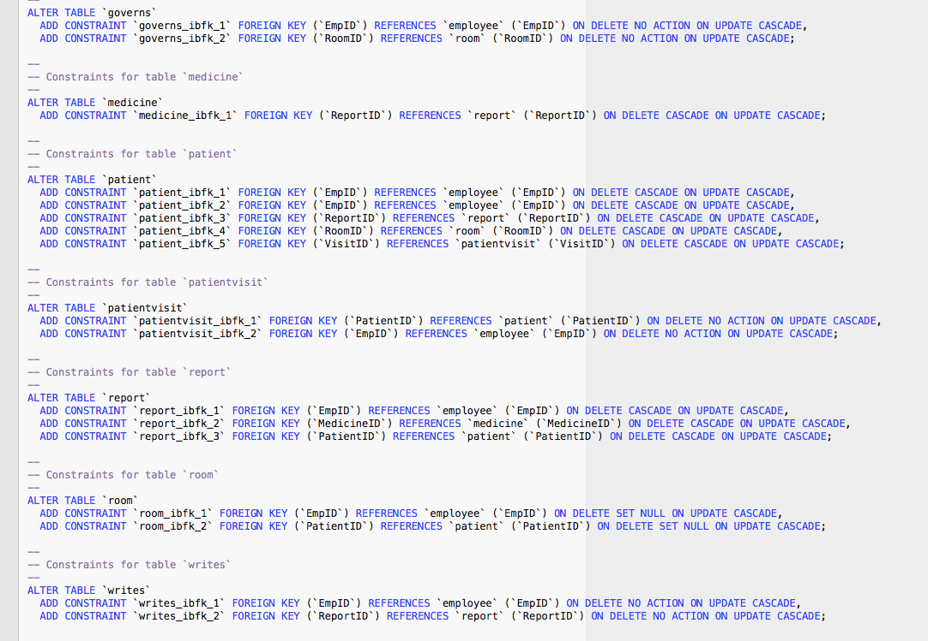

We also created three views, for instance, to make it convenient for administrators to assign patient to a doctor, they can just look up for doctors’ names from the doctor view. We used left

join for roomstatus to look for all rooms. We joined three tables: employee, patient and room to show occupiedroom. The picture shows the three views:

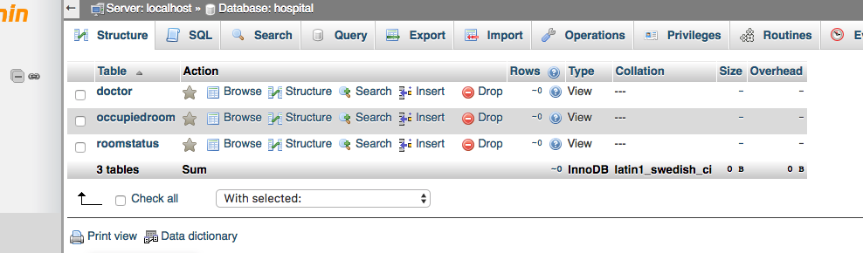

In conclusion, we truly believe this system can organize a small to medium-sized hospital and help them to have more access control and better management ability to their database. We decided to limit to three type of users: administrators, patient and employee to eliminate unnecessary management waste. We included all type of employees in the employee category. To ensure integrity constraints, we made sure that email addresses are unique for all users. For patients, each patient has a unique ID. For employees, they have unique IDs and we made sure the empID is shared in other relations.

The following images display different interfaces that have not introduced in the article:

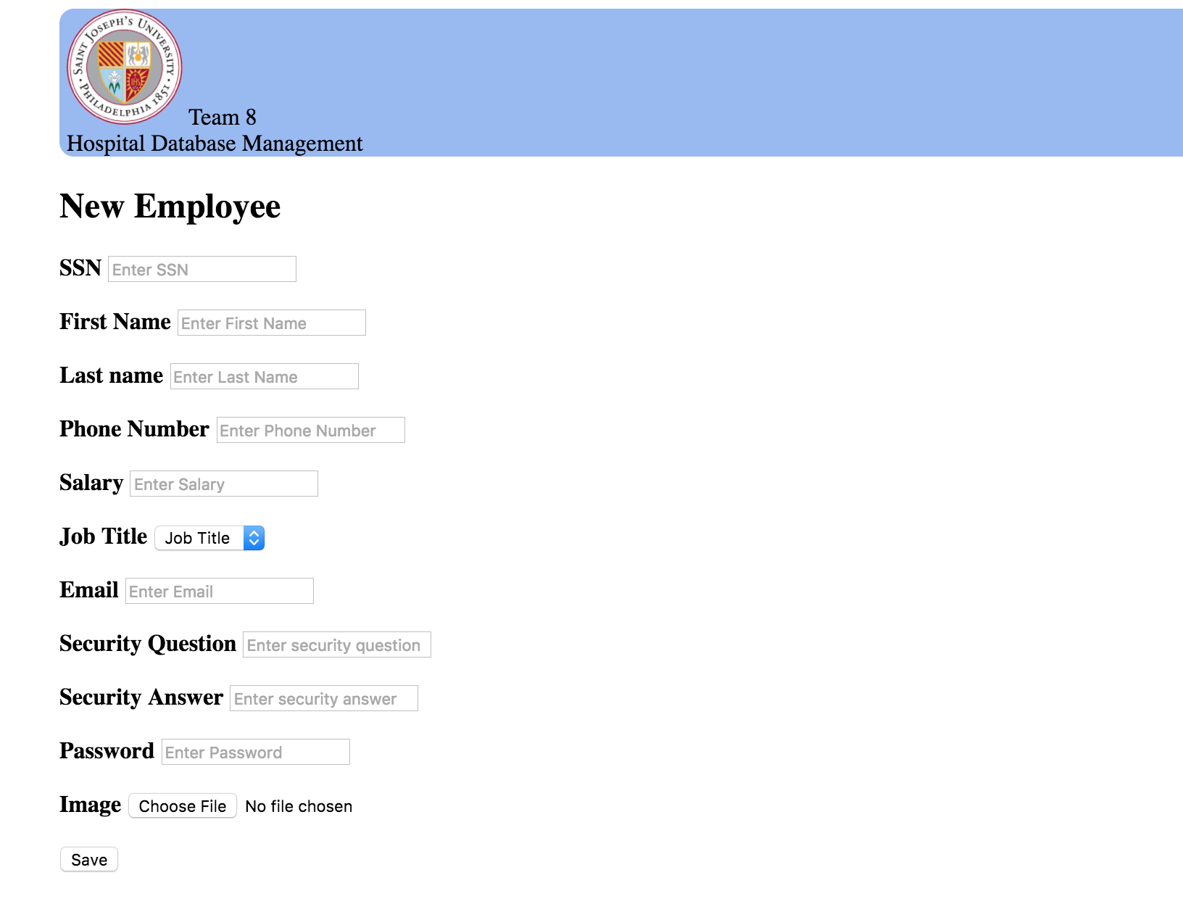

Administrator’s option to add new employee

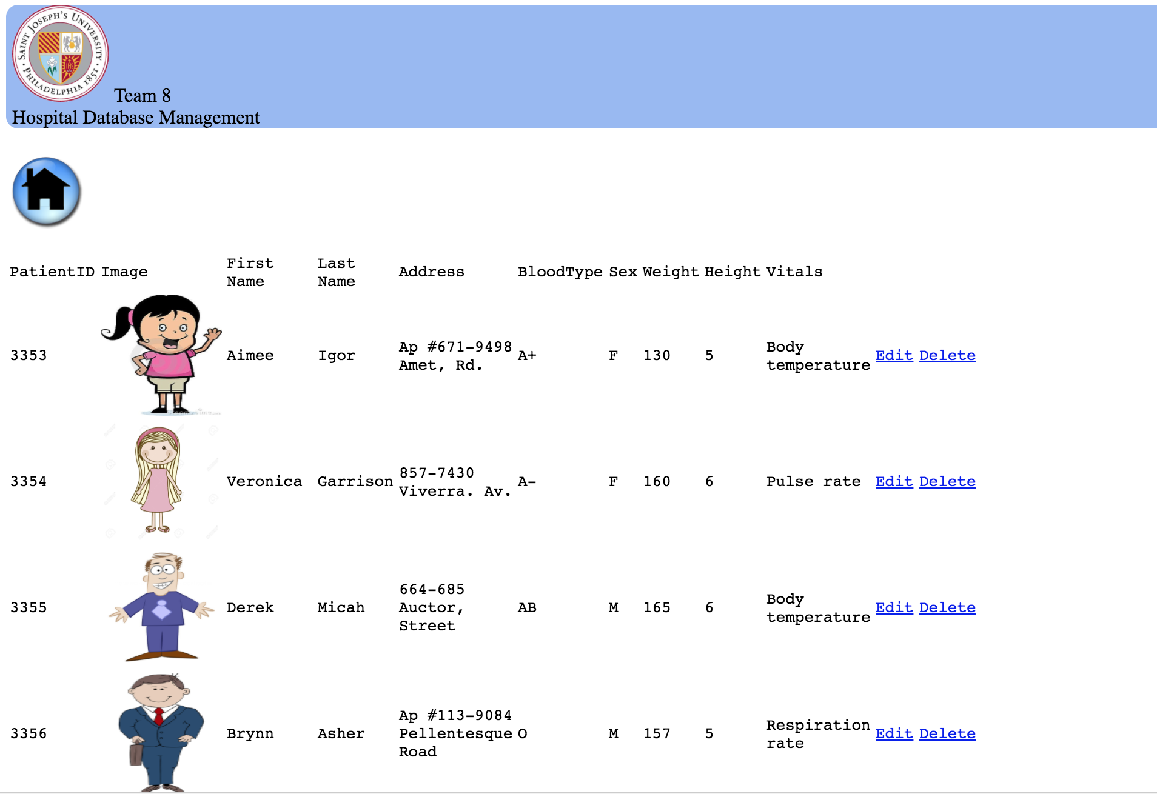

Administrator’s option to see all patient’s profile.

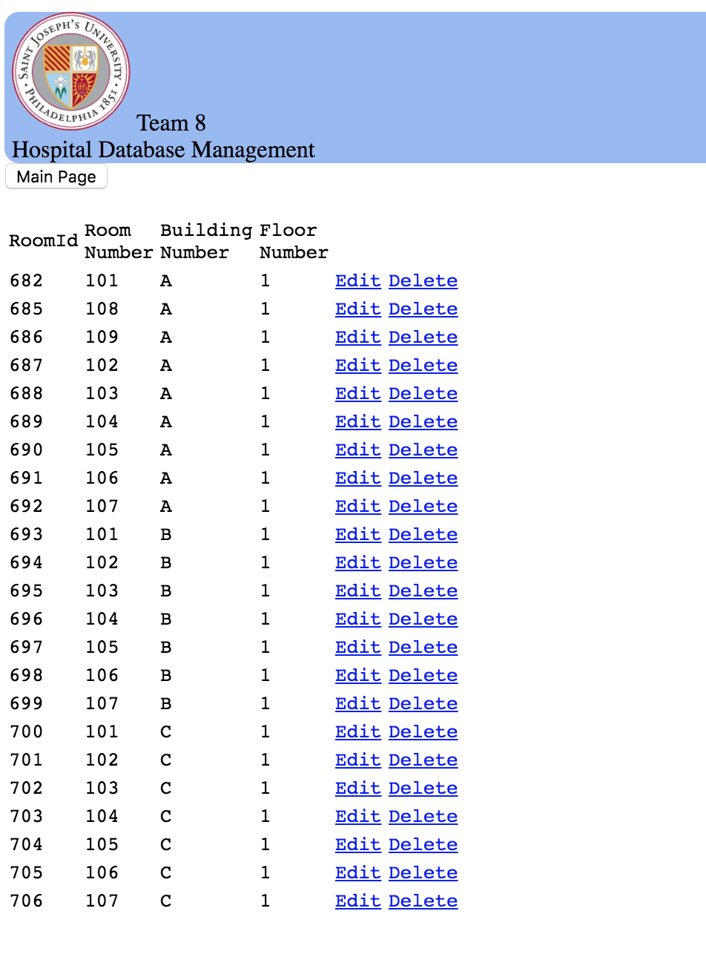

All room information.

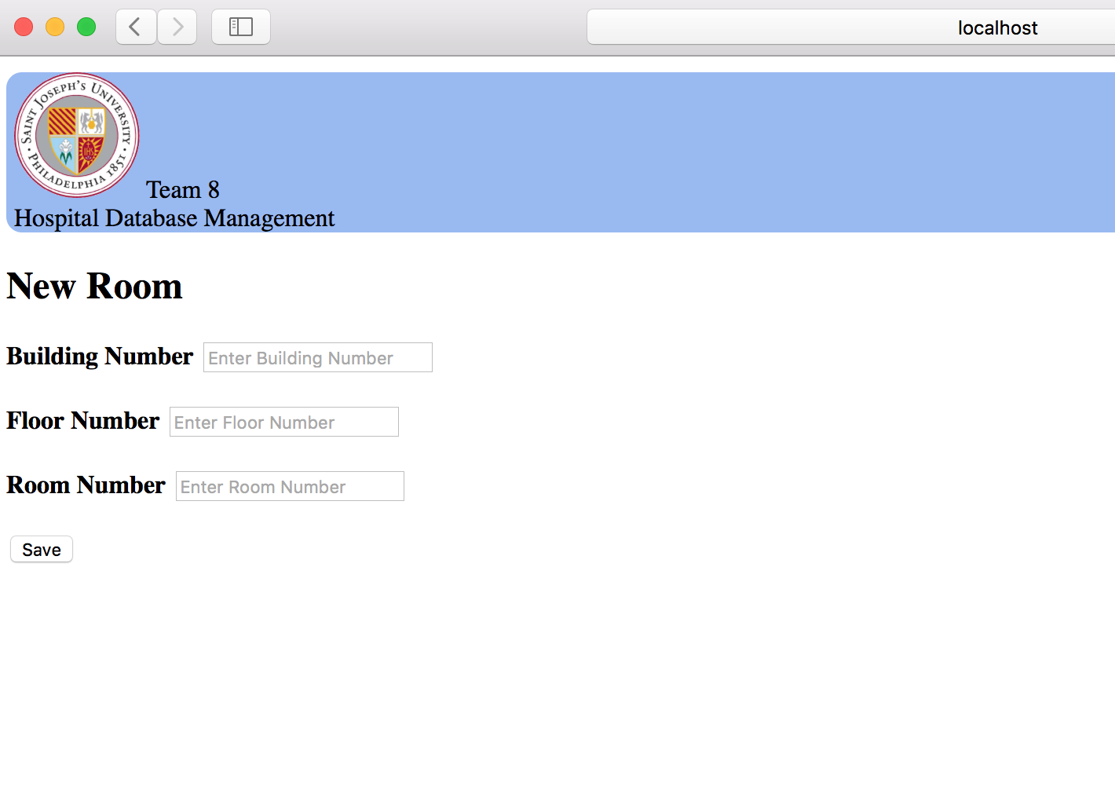

Add new room page.

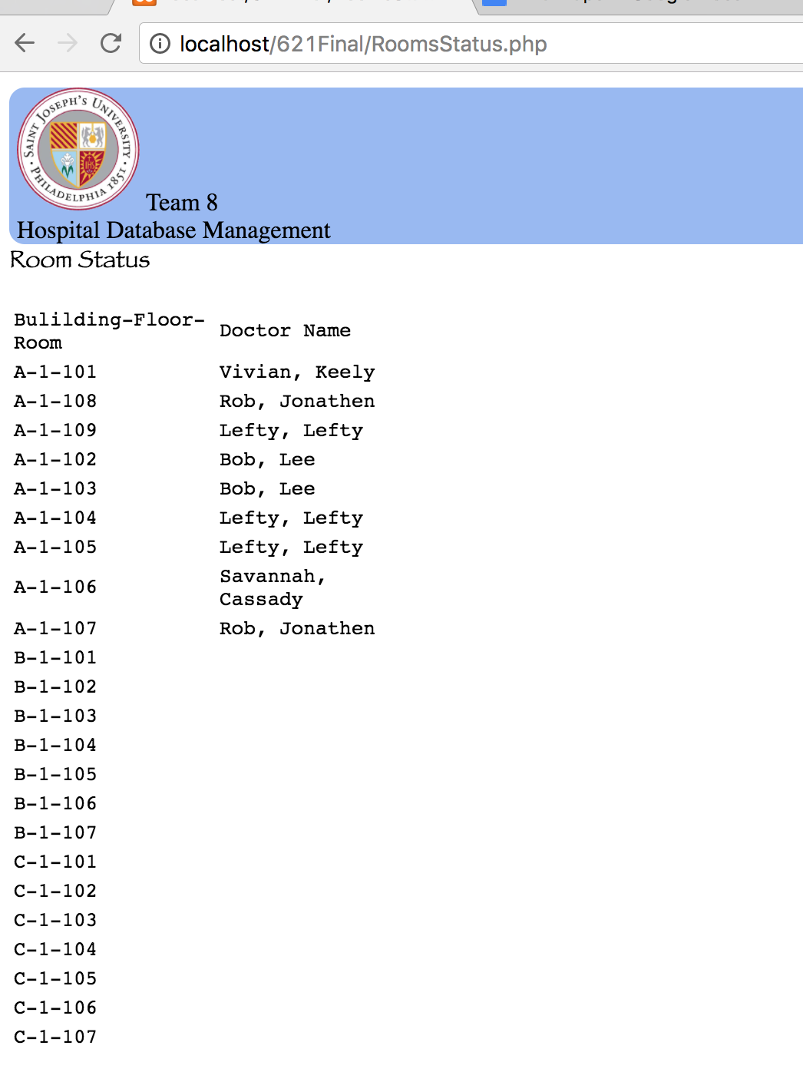

Check room availability

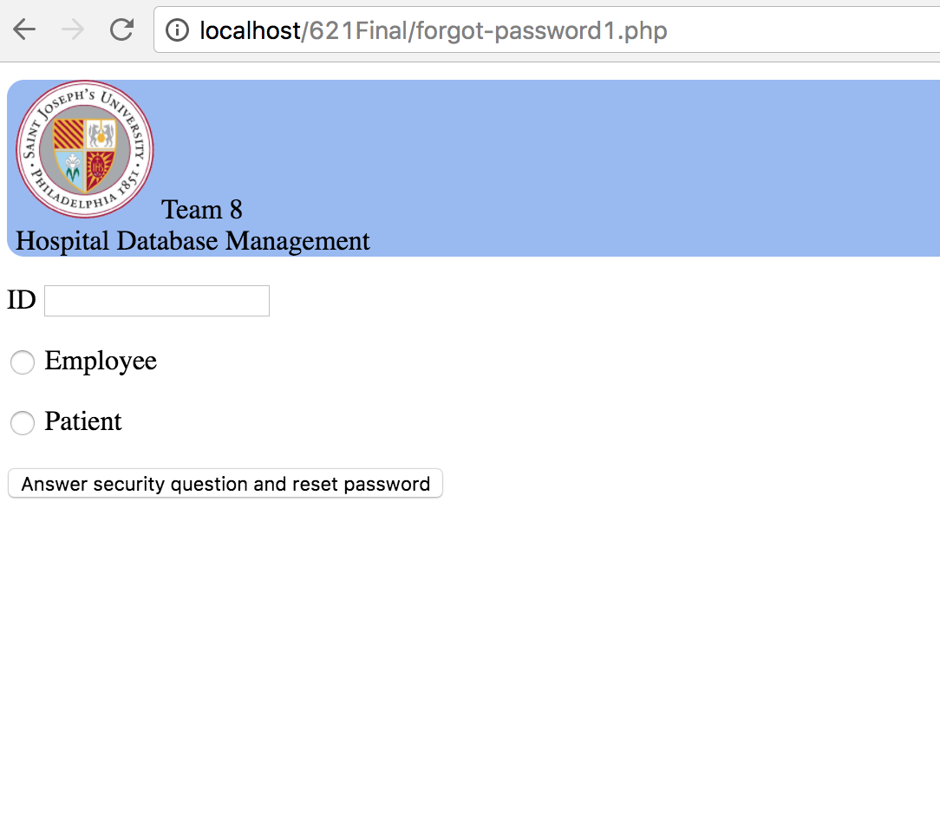

Forgot password page

Github link:

<https://github.com/githubyuch106/621Final>